China and the Uyghurs: Genocide and Transnational Repression

Instructions: Do not read text in [brackets]. When [click] appears in the text, use your mouse or keyboard to advance the slide. The PowerPoint presentation has animations which will make text and graphics appear on the screen.

PowerPoint slide | Script
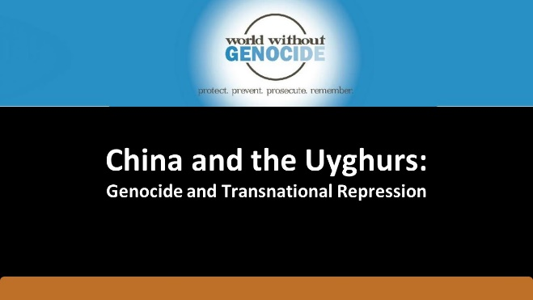 | I’m speaking today about the Uyghurs (“wee gurs”), a minority group who is concentrated in western China. The Chinese Communist Party, or CCP, is accused of perpetrating genocide against the Uyghurs. [click]
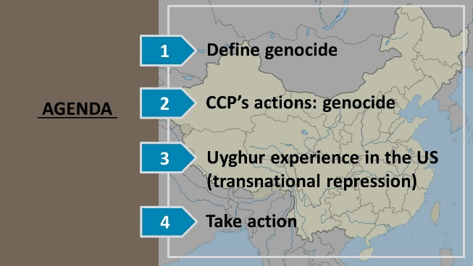 | This presentation consists of three parts: [click]  First, we will define genocide. [click]  Second, we will discuss the CCP’s actions against the Uyghurs that constitute genocide. [click]  Third, we will explore the experience of Uyghurs who have come to the US for safety. These Uyghurs experience threats of violence and harassment by the Chinese government, even though they live in the US – not China. This is a federal crime called transnational repression, and the Chinese government perpetrates this crime on Uyghurs living around the globe. [click]  Fourth, we will discuss action steps to combat transnational repression and support Uyghur populations. [click]
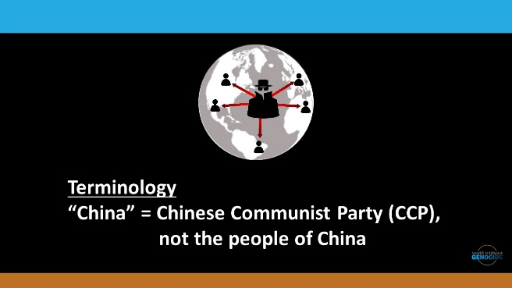 | We will put a face to these global issues. Although China is far away, these issues affect real people’s lives, and they affect the lives of people in the US and in other countries, such as Australia and Canada, where Uyghurs have fled seeking safety.  I’ll talk about the reasons for the Chinese Communist Party’s campaign against the Uyghurs and the global and national efforts to address the genocide. [click]  A word on terminology: when I say “China,” I mean the Chinese Communist Party, the CCP, NOT the people of China. [click]
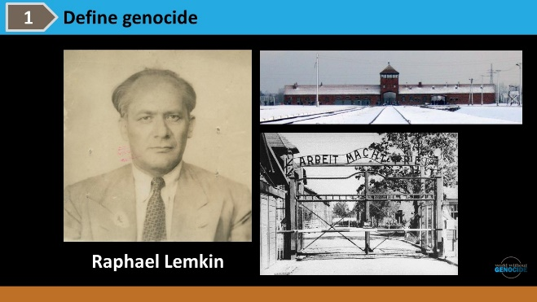 | What is genocide? Raphael Lemkin was a Polish Jew who fled from the Nazis. He tried unsuccessfully to get his family out of Europe, [click]  but 49 members of his family perished at Auschwitz, on death marches, in ghettoes and in slave labor camps.  At that time, before World War II, there were words to describe the killing of a person – homicide, suicide, fratricide – but there was no word to describe the killing of an entire people. [click]
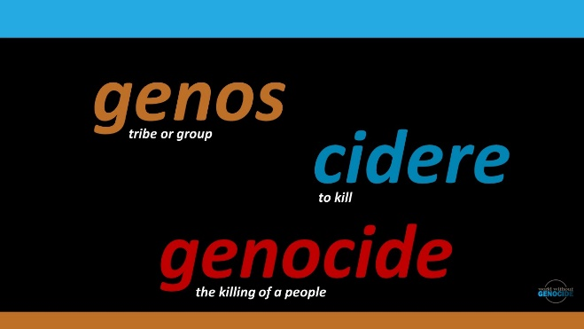 | He was a jurist and a linguist. [click] He took the Greek root ‘genos,’ meaning tribe or group or people, [click] and the Latin verb ‘cidere’ (“si-derry”) meaning to kill, [click] and he coined the word genocide, the killing of a people.  Once he had the definition, he wanted to prevent and punish the crime. He wrote the Convention on the Prevention and Punishment of the Crime of Genocide, [click]
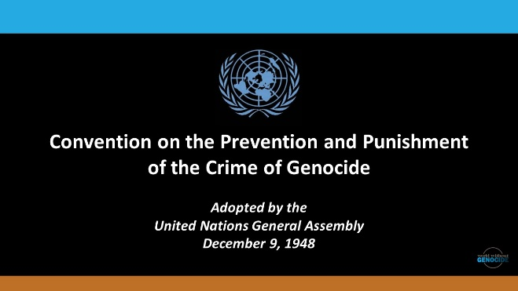 | which the United Nations ratified in 1948. A UN Convention legally binds the country that makes it part of their law. [click]
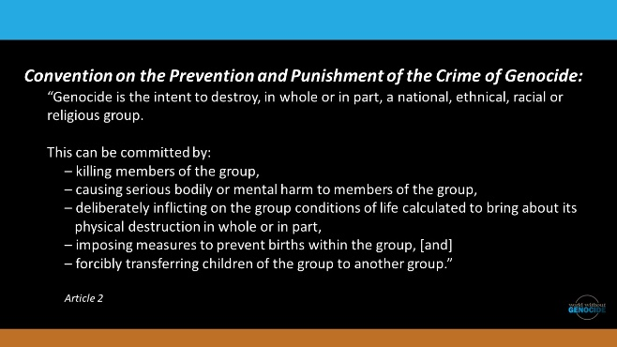 | Genocide is the intent to destroy, in whole or in part, a national, ethnical, racial or religious group. This can be committed by killing members of the group, causing serious bodily or mental harm to members of the group, deliberately inflicting on the group conditions of life calculated to bring about its physical destruction in whole or in part, imposing measures to prevent births within the group, and forcibly transferring children of the group to another group. [click]
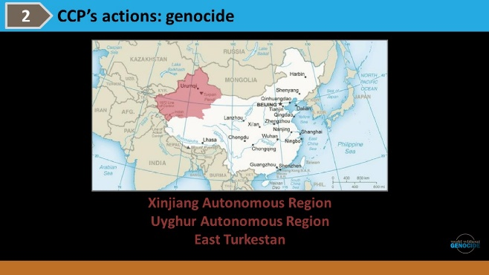 | Now, let’s apply this definition to what is happening against the Uyghur people in China. Most Uyghurs live in China’s Xinjiang (“shin-jaang”) province, shown in red. [click]  Uyghurs call this area “the Uyghur Autonomous Region” or “East Turkestan.” There are about a million Uyghurs in the region, nearly half the population of the province.  The Chinese government claims that Xinjiang (“shin-jaang”) has always been part of China, but the region’s history is more complicated. In 1949, a separatist group declared independence for East Turkestan. It didn’t last long. China established a communist state and quickly regained control of East Turkistan.  In the 1990s, the Uyghurs again wanted to separate from China. There was a violent uprising and in response, China increased its control in the region. [click]
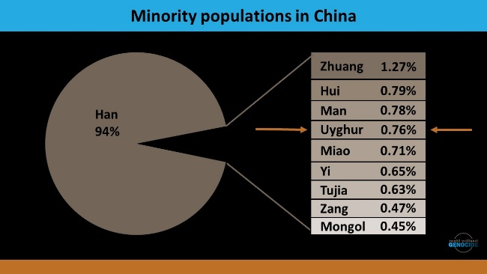 | The Han people compromise 94% of China’s population. The Uyghurs are less than 1% of the population of China, .7%.  There are many minority groups in China and they are singled out for discriminatory treatment. China wants its people to be ethnically homogenous so the government can maintain social control more easily.  Anti-Muslim sentiment rose in the US after the 9-11 attacks. China used this as an excuse to strike out against the Uyghurs, who are Muslim. The Chinese government claimed that the Uyghurs are Muslim terrorists and that they threatened China’s security. This anti-Muslim rhetoric gave China international support for its actions.  After 9-11, Uyghurs held protests about the discrimination against them, and they increased their efforts for independence. [click]
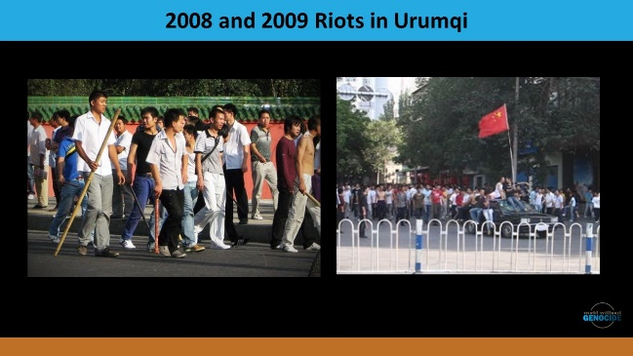 | Uyghurs held mass demonstrations In Ürümqi (“ah-rumchee”), the capital city in Xinjiang (“shin-jaang”). They were protesting the deaths of Uyghurs who were in police custody, a ban on women wearing headscarves, and they wanted regional independence. The government cracked down on them. [click]  Riots broke out again in Ürümqi (“ah-rumchee”) a year later. The government arrested hundreds of Uyghur protestors and sentenced 26 Uyghurs to death. [click]
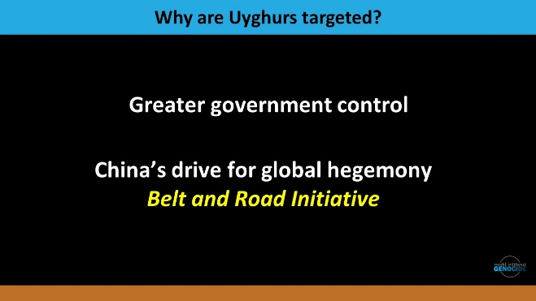 | Why are the Uyghurs specifically targeted? There are two reasons. [click]  First, China wants to have more government control over its people. The Chinese government stamps out attempts at independence to get greater government power. [click]  Second, China wants global dominance over other countries. This is happening through the Belt and Road Initiative, or BRI. [click]
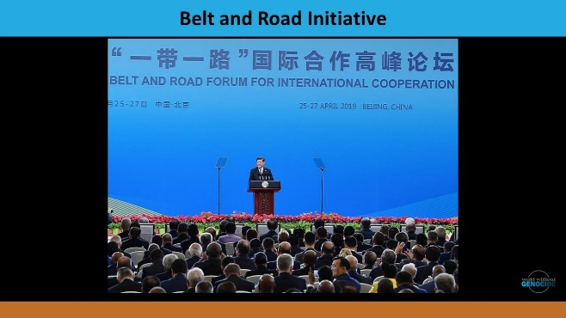 | In 2013, Chinese President Xi Jinping (“Shee Jin Ping”) launched the BRI. This short video explains the BRI. [click]
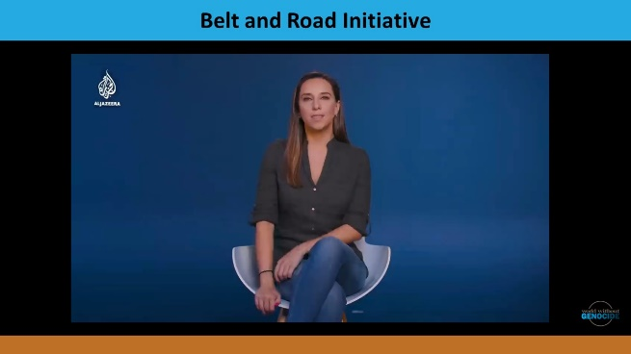 | [play video, 2.3 minutes]  The genocide of the Uyghurs has a direct connection to the BRI. [click]
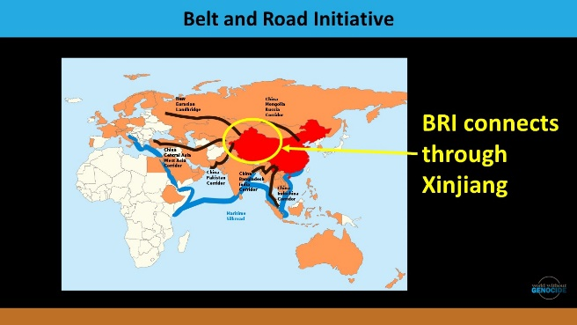 | Xinjiang (“shin-jaang”) is crucial for the successful expansion of the BRI. [click]  Three of the six BRI economic corridors connect right through Xinjiang. China needs control over Xinjiang. And the Uyghurs are in the way – their presence in the region obstructs Chinese development. China specifically wants that area of land. What’s under the ground in Xinjiang? [click]
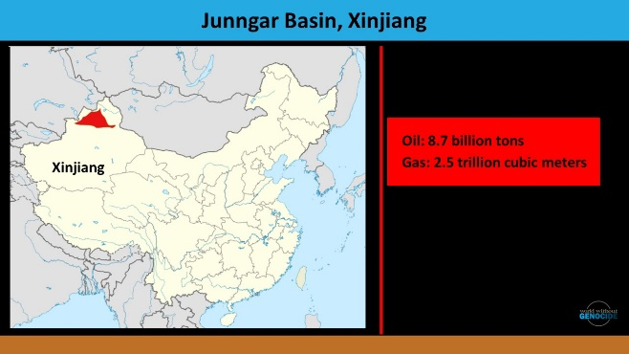 | Oil. Xinjiang produced 35 million tons of crude oil in 2020, a million barrels of oil a day, from the Junngar Basin. Xinjiang also has China's largest coal and natural gas reserves. And the Uyghurs are sitting on these resources, including rare earth elements.  But the Uyghurs are in the way in terms of their identity as well. They are the majority of the population in Xinjiang, despite being such a small percent in the country. [click]
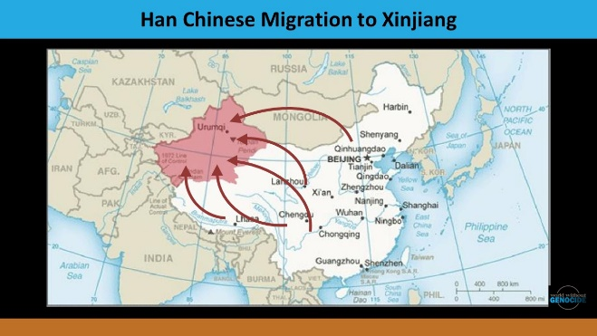 | The government sponsors Han people to move into Xinjiang to dilute the Uyghur presence. China offers special benefits for Han Chinese who relocate. The in-migration of Han people was significant from 1995-2010 and it increased in past years. [click]
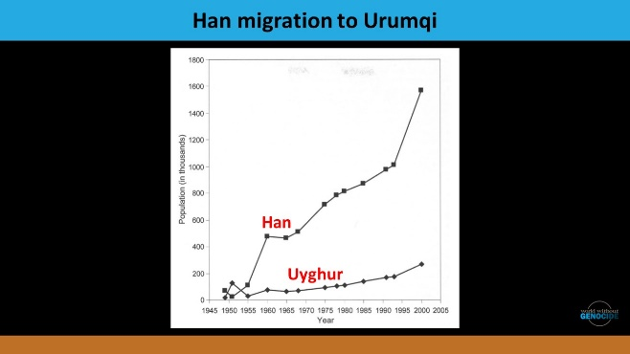 | The population change in Xinjiang’s capital city, Ürümqi, is dramatic – a huge increase of Han people from 1950 to the present. [click]
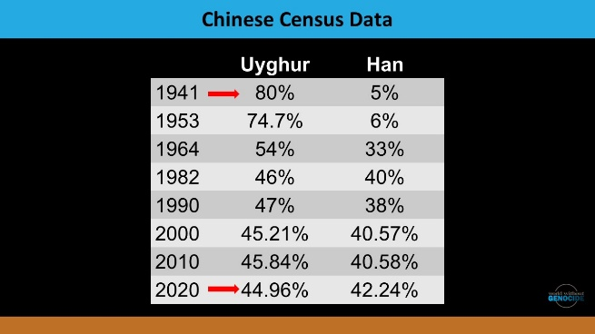 | Uyghurs were 80% [click] of the Xinjiang population in 1941. Eighty years later, [click] it was only 44.96%, or down by half. The Han have increased from 5% to 42%. The Uyghurs are still the single largest ethnic group in the region – by 2%, not 75%, like in 1941.  In 2014, right after the launch of the Belt and Road Initiative, the Chinese government implemented the Strike Hard Campaign against Violent Terrorism in Xinjiang. The government said it was a crime-fighting and border control measure, but the real purpose was to prevent Uyghur activism. [click]
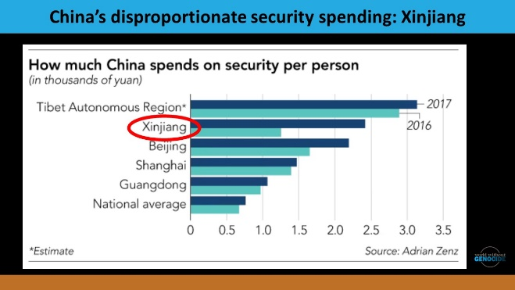 | This shows the spending on security per person in various places in China. The security costs in Xinjiang are second only to Tibet and nearly doubled from 2016 to 2017, five times the national average. What’s the money being spent on? [click]
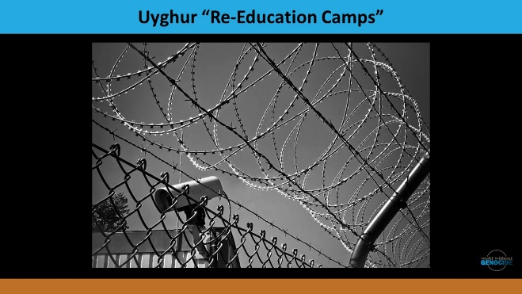 | At least a million Uyghurs are held in concentration camp-like facilities where they are forced to denounce, or give up, Islam. If they aren’t compliant, they are tortured with waterboarding, sexual violence, and solitary confinement. The Chinese government describes these detention centers with euphemisms such as “vocational education and employment training sites for criminals guilty of minor offenses.” Documentation shows 500 detention centers and prisons. [click]
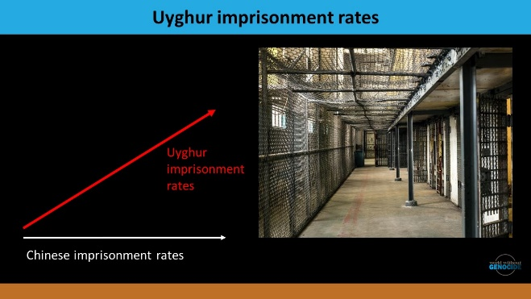 | Uyghurs are also incarcerated in China’s official prisons. [click]  When the Strike Hard campaign began, Uyghur imprisonment rates increased drastically. [click] Chinese imprisonment rates remained constant, while Uyghur imprisonment rates rose sharply. [click]
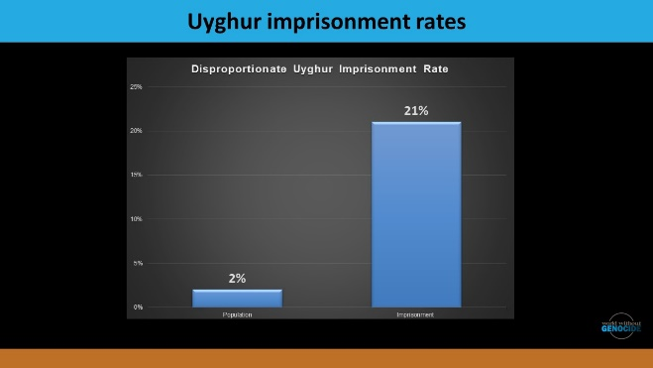 | Uyghurs are less than 2% of the population but 21% of China’s total prison population. And 87% of prisoners in Xinjiang were sentenced to prison terms of 8 years or more, compared to 14% of prisoners in the rest of China.  What else is happening? [click]
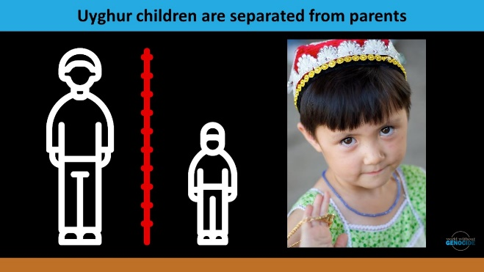 | China is separating Uyghur children from their families. [click]  When adult Uyghurs are sent to prisons and detention centers, children are sent to boarding schools – just like the U.S. and Canadian governments did to Native children.  Uyghur children report torment in these schools. [click]
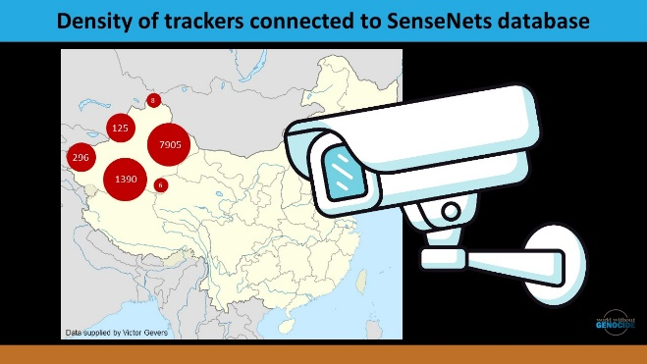 | China is one of the most technologically advanced countries in the world. The government monitors the Uyghurs using facial recognition technology, smartphone scanners, spyware on devices, and biometric data. This map shows the density of trackers connected to surveillance databases. [click]
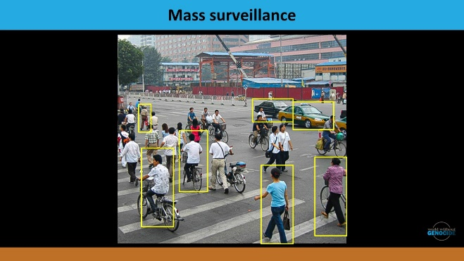 | Human Rights Watch (HRW) reports that mobile apps monitor Uyghurs to surveil for activists and dissenters. Police officers use smart glasses to assess how far a person has traveled from their registered address. AI monitors behavior to predict which individuals are threats to the Chinese authorities. [click]
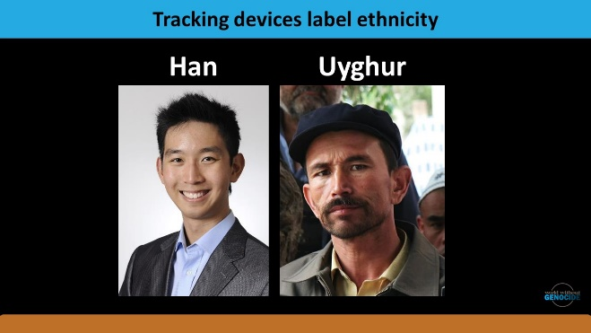 | Huawei and other companies have created tracking devices to label people using racist stereotypes.  Chinese technology stalked Uyghurs as early as 2013, at the beginning of the Belt and Road Initiative, in China and in at least 15 other countries.  The New York Times calls the effort a police state. [click]
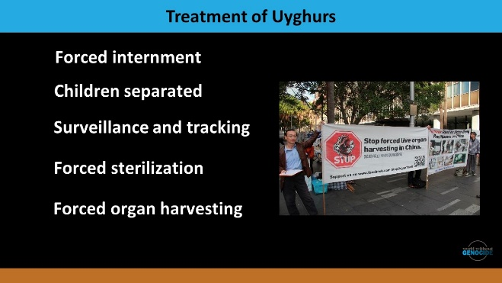 | Internal Chinese documents show forced [click] IUD birth control placements into 524 women and forced sterilizations of 14,872 people. [click]  Reports show that Uyghurs are subjected to forced harvesting of their body organs for the global black market in organ transplants.  These crimes against Uyghurs constitute cultural and physical genocide. China is intentionally eradicating the Uyghur culture and the Uyghur people. [click]
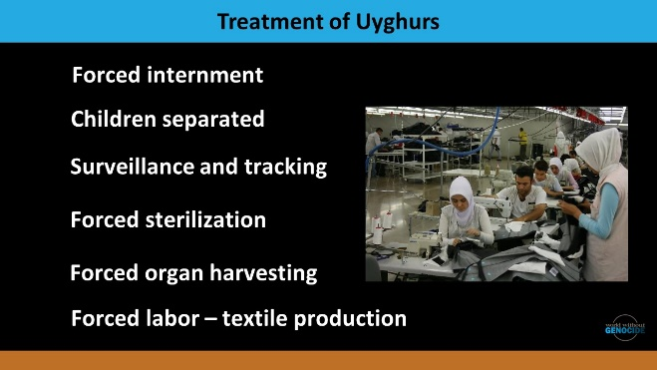 | A branch of the World Bank has significant investments in the Xinjiang region. The investments fund factories and other infrastructure. [click]  Xinjiang produces more than 80 percent of China’s cotton and the Uyghurs are used as slave labor. The World Bank is making money from genocide.  The New York Times reports that about one in five pieces of cotton clothing contains cotton from Xinjiang. [click]
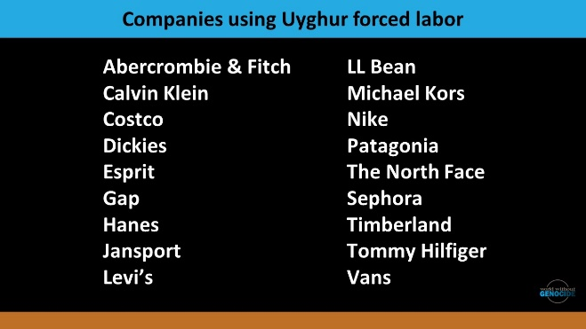 | There are at least 83 companies using Uyghur forced labor. These include well-known companies like Abercrombie, Calvin Klein, Gap, Nike, Patagonia. Are your clothes made through genocide slave labor?  This is the situation today: grievous crimes continue in Xinjiang and other regions. The Uyghurs are in danger. Genocide is occurring – on our watch.  What’s happening to end the impunity for the people carrying out these crimes? [click]
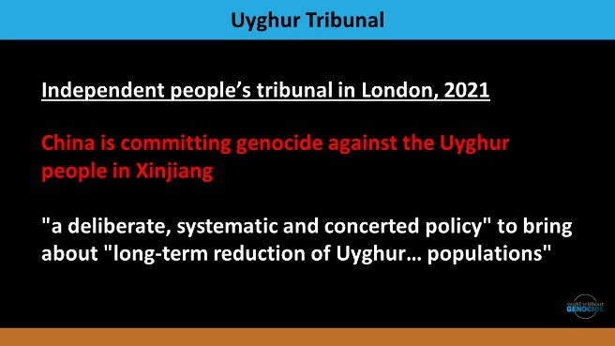 | The independent People’s Tribunal in London conducted extensive investigations and declared that China is committing genocide. But this was an unofficial tribunal with no power to indict, arrest, and prosecute.  China, of course, denies any culpability. [click]
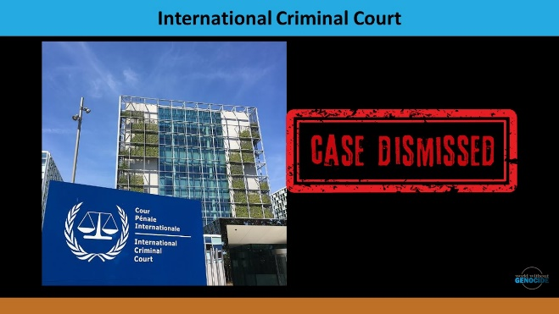 | There was an effort to hold China accountable at the International Criminal Court. However, China is not a signatory to this Court. This means that charges can’t be brought directly against China for actions in Xinjiang. [click] The court dismissed the case for jurisdictional reasons.  A case has been filed in Argentina by two Uyghur human rights groups accusing China of genocide and crimes against humanity. The lawsuit is being led by the British firm, Justice Abroad. [click]
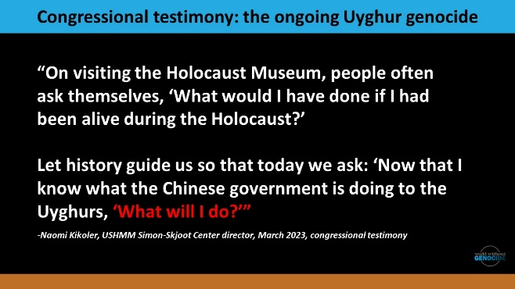 | In the US, many organizations have labeled the atrocities as genocide. The United States Holocaust Memorial Museum holds programs on the crisis, and the director of the Museum’s Center for the Prevention of Genocide testified about “the ongoing Uyghur genocide.”  You see part of the director’s statement, including the words “What will I do?” [click]
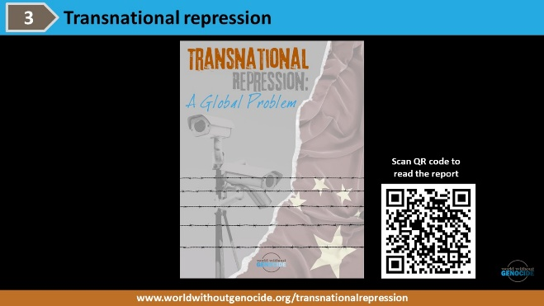 | World Without Genocide, a human rights organization headquartered at Mitchell Hamline School of Law in St. Paul, MN, conducted a study of transnational repression.  Their researchers gathered information from Uyghurs in the US about their experiences of transnational repression and measures they would recommend to improve Uyghurs’ safety and security in the US. In addition, the study asked about the impact of the genocide on their lives and on the lives of their families.  The study included detailed online interviews with Uyghur men and women from across the US. [click]
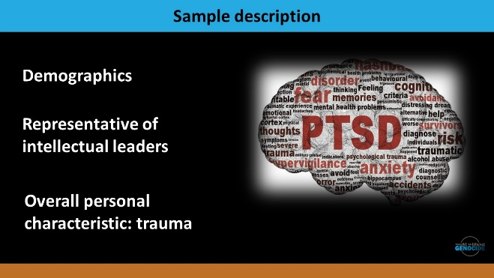 | As of 2022, there was were an estimated 10,000 Uyghurs in the United States. [click] The largest population of Uyghurs is in the Washington, D.C. area. This was true of the study respondents as well.  Refugees from China have consistently represented a slim portion of total admissions to the US in recent years. It is increasingly difficult for Uyghurs and other Turkic Muslims to leave China, and it is very difficult to get entry into the US.  Study respondents had been in the US for a number of years. Most of them originally came to pursue advanced educational degrees. They are therefore an exceptional, and likely an unrepresentative, group of Uyghurs as a whole. They were all fluent in English, and, for the most part, they hold M.A. or Ph.D. degrees. They were perhaps allowed to leave China as part of the Chinese government’s strategy to diminish the power of the Muslim intelligentsia remaining in Xinjiang. Their families were typically well-educated and financially above average. [click]  The practice of eliminating the cultural, social, and business elite of a group that is targeted for genocide is an all-too-common phenomenon. It occurred during the Holodomor in Ukraine; the genocide of the Armenians during World War I; during the Holocaust; during the Cambodian genocide; and now among the vulnerable Uyghur population as well. [click]  Without exception, each respondent was severely traumatized by the genocide occurring in China and each respondent has loved ones in China who continue to be persecuted. [click]
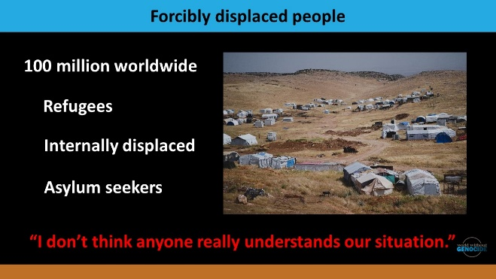 | There are currently nearly 100 million forcibly displaced people worldwide as a result of persecution, conflict, human rights violations, or other disrupting events. [click] These displaced persons include refugees, the internally displaced, and asylum seekers.  Most Uyghurs in the study are seeking or have sought asylum, a legal status that allows an individual to remain in the US instead of being deported to, or returned to, a country where he or she fears persecution or harm.  It is often said that refugees are among the most misunderstood of people in the world, and that’s exactly what one respondent said: [click] “I don’t think anyone really understands our situation.” [click]
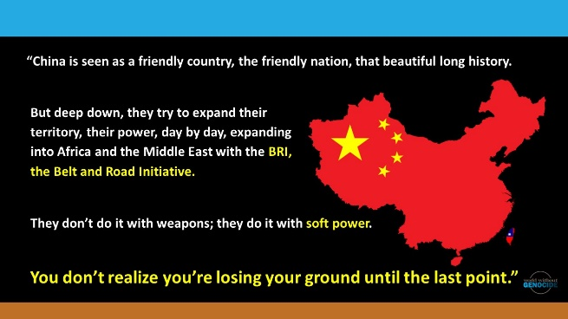 | One respondent said, “China is seen as a friendly country, the friendly nation, that beautiful long history. [click]  But deep down, they try to expand their territory, their power, day by day, expanding into Africa and the Middle East with the BRI [Belt and Road Initiative]. [click]  They don’t do it with weapons; they do it with soft power. [click]  You don’t realize you’re losing your ground until the last point.” [click]
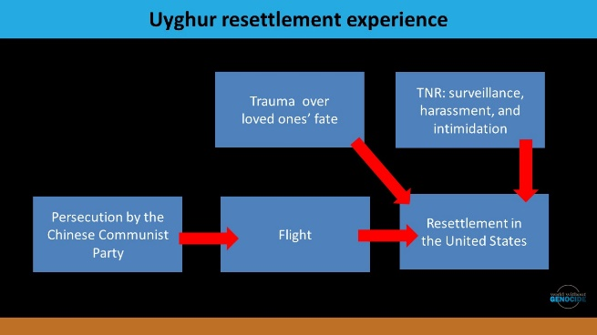 | We can think of their experience by using this diagram, beginning at the bottom left. They were persecuted in their home country, fled, and resettled in the US. But that resettlement is affected by two very profound and unique experiences: what is happening to their loved ones in China, and by the transnational repression here in their new country. [click]
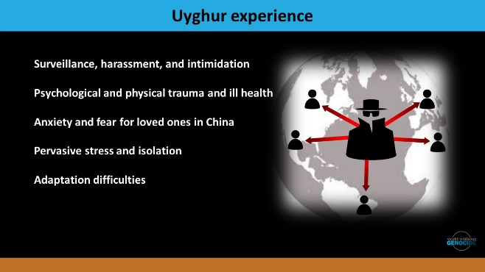 | Surveillance, harassment, and intimidation: all of the Uyghur respondents suspected that their electronic communications had been under surveillance by the Chinese government at some point. Of particular note, respondents reported that there was a sense of surveillance when using WeChat to contact family in Xinjiang.  The Uyghur respondents received messages that they were not to speak out against human rights abuses in the United States; if they did, their family in Xinjiang would suffer consequences, including imprisonment or even death.  Almost without exception, the Uyghur respondents were unable to locate family members in Xinjiang. The lack of communication left some respondents questioning whether their family members had been detained or taken to government-run “reeducation” camps. One respondent reported, quote  “In 2019, I learned my sister had been detained in 2018. I started campaigning on social media to release my sister. Because I was openly talking against the Chinese government, they threatened me over WeChat. I would get a call or threat every day.” End quote. [click]  Psychological and physical trauma and ill health: one respondent reported, quote  “This situation is an enormous stress for me and my family. I have been taking medicine for at least one year because every day I am crying. I cannot control my body. Sometimes I am angry and shaking. It is not good for my children.” End quote. [click]  Anxiety and fear for loved ones in China: All respondents expressed a uniform sense of fear for the safety of their family members remaining in Xinjiang, which has led to a fear of speaking out. [click]  Pervasive stress and isolation: The guilt associated with their own safety, coupled with the powerlessness of not being able to contact or assist loved ones in China, has left most respondents feeling stressed, isolated, and fearful. [click]  Adaptation difficulties: As of 2022, there were an estimated 10,000 Uyghurs in the US, and an estimated 1–1.6 million Uyghurs living elsewhere outside of China.  According to Amnesty International, Uyghurs throughout the diaspora face transnational repression and live with fear, including the threat of deportation back to China. [click]
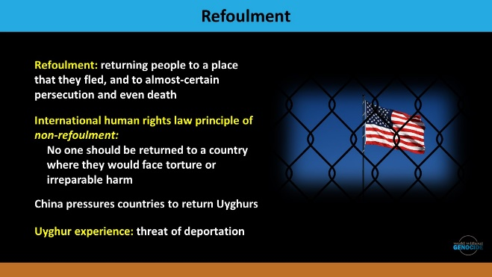 | A critical international issue is refoulement, returning people to a place that they fled and to almost-certain persecution and even death. [click]  The international human rights law principle of non-refoulement guarantees that [click] no one should be returned to a country where they would face torture, cruel, inhuman, or degrading treatment or punishment, and other irreparable harm. This principle applies to all migrants, at all times, regardless of migration status.  Uyghurs who are not legally settled and protected with legal status face an exceptional risk of detention and refoulement. [click]  Since the 1990s, Uyghurs living outside of China have faced efforts by Chinese authorities to pressure foreign governments to forcibly transfer them back to China. Records show that more than 1,500 Uyghurs have been detained or forcibly returned, and many have subsequently faced imprisonment and torture in custody. [click]  This threat of deportation is a tremendous stress for people waiting to receive asylum status, including for those in the US. When their passports expire and their status is in limbo, Chinese authorities tell them that they must return to Xinjiang to renew their passports, and this means almost certain arrest. [click]
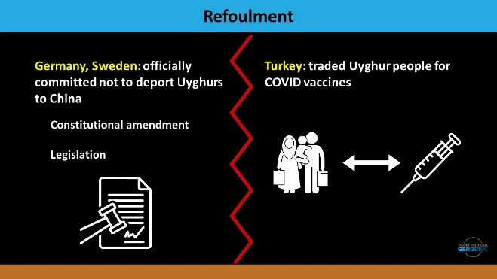 | Since 2018, Germany and Sweden have officially committed not to deport Uyghurs to China. [click] Some states have formalized the prohibition against refoulement in their constitutions or through legislation. [click]  The opposite happens as well: Turkey traded Uyghurs for Covid vaccines. [click]
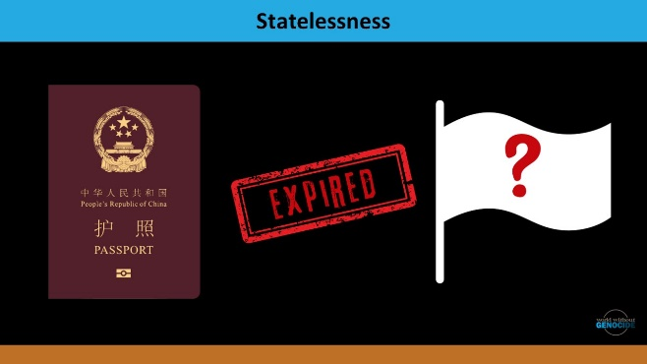 | Some Uyghur people in the US have become stateless. Their passports from China expired, and if they go to a Chinese embassy to renew their documents, they are arrested and deported. They choose to remain here, waiting in limbo for their asylum status. [click]
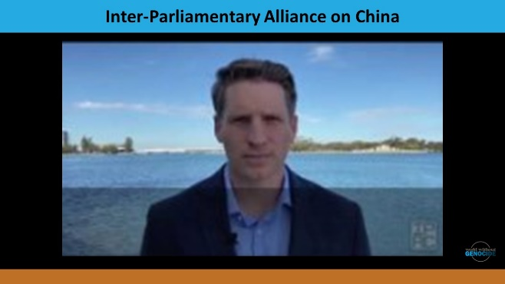 | More than 200 Parliamentarians from 21 countries around the world have prepared a proactive approach to China on upholding human rights and international law. This minute-long video shows a global effort to stand up.  [play video – 1.5 minutes; https://www.youtube.com/watch?v=wNwyI-Bbnvs] [click]
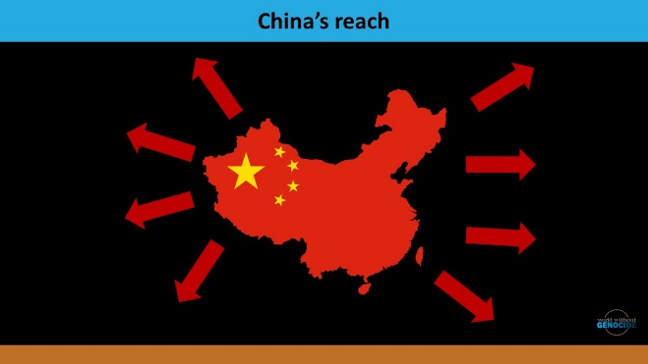 | Genocide is being perpetrated against the Uyghurs. We can all do something.  We can take some action. [click]
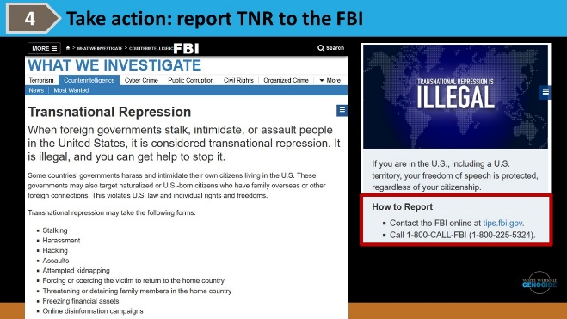 | The FBI has a website that gives information about this crime. [click]  Report to the FBI any efforts by agents of foreign governments to stalk, intimidate, or assault people in the US. You can do it online or by phone. [click]
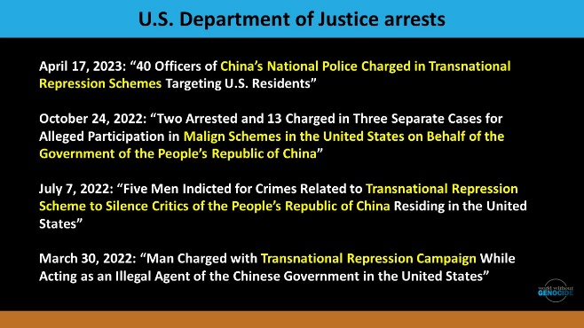 | Arrests for China’s transnational repression have been well-publicized, in recent years. Transnational repression cases involving agents of the Government of the People’s Republic of China are well-documented. [click]
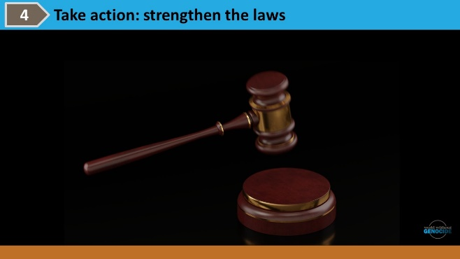 | Some types of transnational repression currently fall outside the scope covered by existing U.S. law. Ask your U.S. Senators and Representative to support pending legislation pertaining to transnational repression. [click]
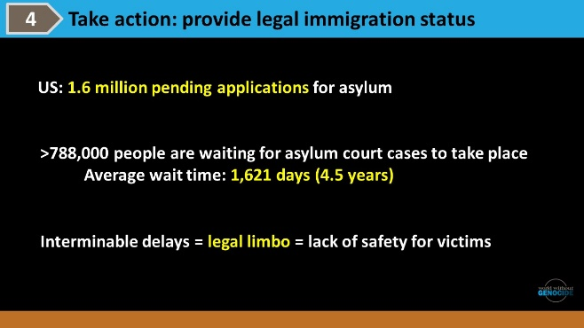 | As of 2023, U.S. Citizenship and Immigration Services (USCIS) had [click] nearly 1.6 million pending applications for asylum. [click]  More than 788,000 people are waiting for court hearings in their asylum cases. [click] The average wait time is 1,621 days — nearly four and a half years. [click]  Many of our respondents spoke about these interminable delays that leave them in legal limbo. Without official legal status in the US, they don’t feel safe from harassment. The backlog must be addressed.  One respondent said, quote  “The asylum process is very wrong. Even with the genocide declaration [of China’s actions against the Uyghurs], it still takes a long time to get an interview. I keep getting threats from the authorities in China. If I could have my status confirmed, that would be nice, but that will be a long time. I think that because of what we suffered, very little else matters.” End quote. [click]
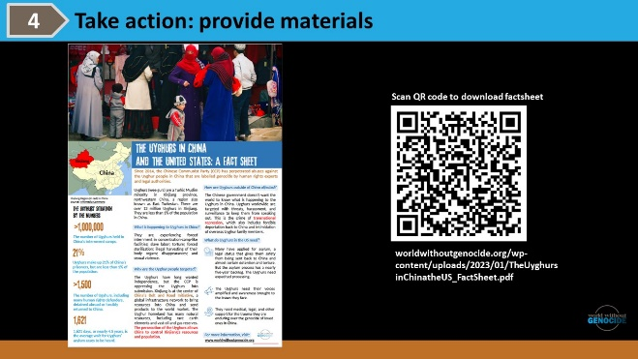 | Each time a refugee or asylee tells their personal story, they are re-traumatized. World Without Genocide has a factsheet to share with health-care providers, children’s teachers, attorneys, and others.  The factsheet is available at no cost. [click]
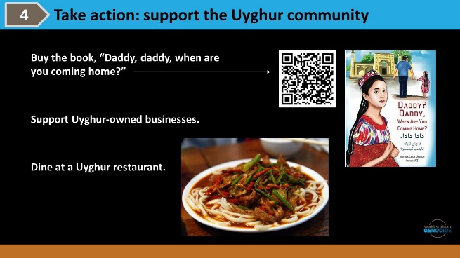 | Buy the book, "Daddy? Daddy, when are you coming home?," available on Kindle and in paperback. This beautiful children's book raises awareness about Uyghur culture and genocide. Order copies as gifts. Buy the book for your local library and for elementary schools. [click]  Look up a Uyghur business to support. [click]  Dine at a Uyghur-owned restaurant. [click]
