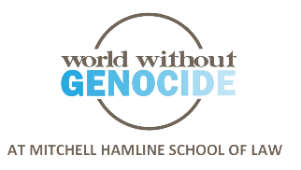
Cities with CEDAW Resolutions

California  Berkeley  Daly City  Laguna Woods  Long Beach  Los Angeles  Pittsburg  San Francisco  San Jose  Santa Clara  Santa Monica  West Hollywood  Colorado  Ashland  Boulder  Greeley  Lafayette  Louisville  Florida  Sarasota  St. Petersburg  Tampa  Hawaii  Honolulu  Kentucky  Louisville | Louisiana  New Orleans  Minnesota  Duluth  Edina  Minneapolis  Red Wing  Richfield  St. Paul  Northfield  Missouri  Kansas City  University City  New York  Mount Vernon  North Carolina  Durham  Ohio  Cincinnati  Oregon  Ashland  Eugene  Pennsylvania  Pittsburgh | South Carolina  Columbia  South Dakota  Rapid City  Utah  Salt Lake City  Wisconsin  Appleton  Madison  Milwaukee  Washington, D.C.  Counties  Boulder, CO  Durham, NC  Miami-Dade, FL  Santa Clara, CA  States  California
http://citiesforcedaw.org/resources/ with additional data and updated May 2021

