SF 1703

A bill for an act
relating to state government; establishing the American Indian and Indigenous
Peoples Day; proposing coding for new law in Minnesota Statutes, chapter 10.
BE IT ENACTED BY THE LEGISLATURE OF THE STATE OF MINNESOTA:

Section 1.

[10.556] AMERICAN INDIAN AND INDIGENOUS PEOPLES DAY.
Subdivision 1. new

Observance. new text end
The second Monday in October shall be known as American Indian and Indigenous Peoples Day to acknowledge and promote the well-being and growth of Minnesota's American Indian and Indigenous community. American Indian and Indigenous Peoples Day shall be used to reflect upon the ongoing struggles of indigenous people in this state, and to celebrate the thriving culture and value that Dakota, Ojibwe, and other indigenous nations add to our state.

Subd. 2.

State recognition.
The state recognizes the annexation of Dakota and Ojibwe homelands for the building of our state and recognizes that American Indian and Indigenous nations have lived upon this land since time immemorial and the state values the progress our society has accomplished through American Indian culture, knowledge, technology, and thought. The state has a strong history of collaboration with American Indian tribes and indigenous communities in solving pressing issues for American Indian tribes and indigenous communities.

Subd. 3.

Disparities.
The state understands that in order to close persistent and pervasive disparities, government entities, organizations, and other public and private institutions are encouraged to change their policies and practices to reflect the experiences of American Indian people and our country's indigenous roots, culture, history, and significant contributions. Businesses, organizations, and public and private entities are encouraged to recognize and participate in the American Indian and Indigenous Peoples Day in order to close disparities.

Indigenous Peoples’ Day: History and Overview
Indigenous Peoples' Day (also known as Native American Day) is celebrated in various localities in the United States, begun as a counter-celebration to Columbus Day. The purpose of the day is to promote Native American culture and commemorate the history of Native American peoples. The celebration began in Berkeley, California, and Denver, Colorado, as a protest against Columbus Day, which is listed as a federal holiday in the United States, but is not observed as a state holiday in every state. Indigenous Peoples' Day is usually held on the second Monday of October, coinciding with the federal observance of Columbus Day.
The idea of replacing Columbus Day with a day celebrating the indigenous people of North America first arose in 1977 from the International Conference on Discrimination Against Indigenous Populations in the Americas, sponsored by the United Nations.
In 1992, the city council of Berkeley, California, declared October 12 a "Day of Solidarity with Indigenous People," and 1992 the "Year of Indigenous People," and implemented related programs in schools, libraries, and museums. The city symbolically renamed Columbus Day to "Indigenous Peoples' Day" beginning in 1992 to protest the historical conquest of North America by Europeans and to call attention to the demise of Native American people and culture] through disease, warfare, massacre, and forced assimilation. Performances were scheduled that day for Get Lost (Again) Columbus, an opera by a Native-American composer. Berkeley has celebrated Indigenous Peoples' Day ever since. Beginning in 1993, Berkeley has held an annual powwow and festival on the day.
In the years after Berkeley's move, other local governments and institutions have either renamed or canceled Columbus Day, either to celebrate Native Americans, to avoid celebrating actions of Columbus that led to the colonization of America by Spanish conquistadors, or due to controversy over the legacy of Columbus. Two other California cities, Sebastopol and Santa Cruz, now celebrate Indigenous Peoples' Day.
At least four states do not celebrate Columbus Day (Alaska, Hawaii, Oregon, and South Dakota) with South Dakota officially celebrating Native Americans’ Day instead. Various tribal governments in Oklahoma designate the day "Native American Day," or name the day after their own tribe. In 2013, California considered a bill, AB55, to replace Columbus Day formally with Native American Day.
Some Native Americans formally celebrate Indigenous Peoples' Day instead of Columbus Day. One way this occurs is a sunrise ceremony on Alcatraz Island in the San Francisco Bay.
In April 2014, the city council of Minneapolis, Minnesota, officially voted to recognize Indigenous Peoples' Day instead of Columbus Day. This was followed in October by the city council of Seattle, Washington officially recognizing the holiday.
The City Commission of Traverse City, Michigan, passed a Resolution recognizing Indigenous Peoples Day on February 2, 2015. In August 2015, the city of St. Paul, Minnesota unanimously passed a resolution to officially recognize Indigenous Peoples Day.
In 1994, the United Nations declared an International Day of the World’s Indigenous People, but, concerned about upsetting some member nations, chose August 9 instead of the traditional Columbus Day. There has been some annual international celebration on August 9 ever since.
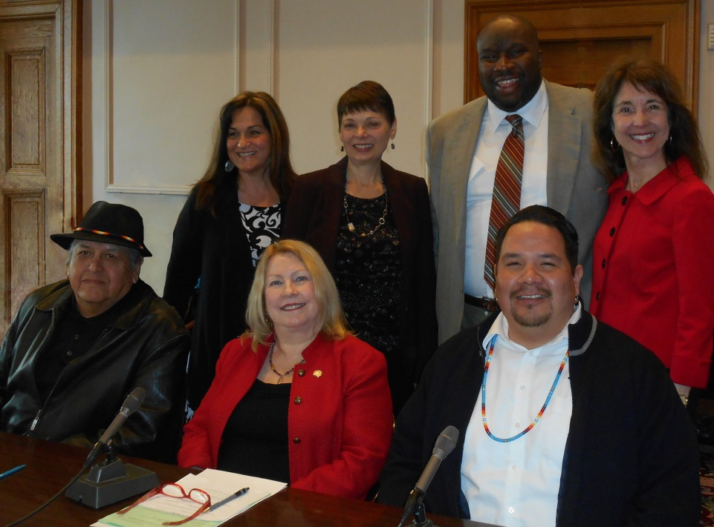
Photo credit: Ellen Kennedy; taken at Minnesota Senate hearing, spring 2015

