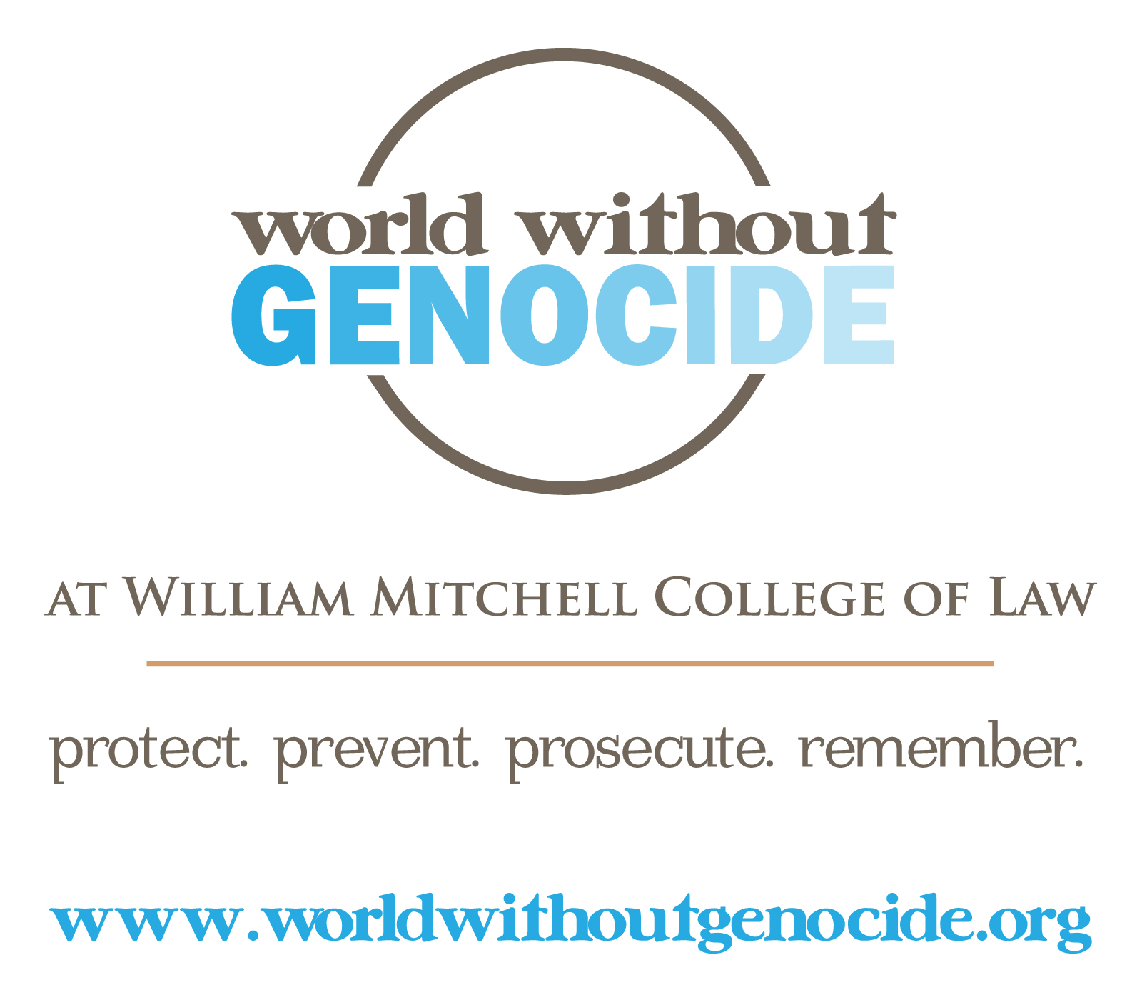
References: Human Trafficking
Hotlines
Department of State Trafficking Hotline: 1-888-428-7851
National Human Trafficking Resource Center: 1-888-3737-888
Text to Be Free (Polaris Project): Text HELP or INFO to BEFREE (233733)

Organizations: Minnesota

The Advocates for Human Rights: www.theadvocatesforhumanrights.org
Breaking Free: www.breakingfree.net
Heartland Girls’ Ranch: www.heartlandgirlsranch.org
Catholic Charities: www.cctwincities.org
Civil Society: civsociety.org
The Link: www.thelinkmn.org
Men Against the Trafficking of Others: mattoo.org
Minnesota Center Against Violence and Abuse: www.mincava.umn.edu/categories/935
Minnesota Coalition Against Sexual Assault: www.ijm.org
Minnesota Human Trafficking Task Force: www.mnhttf.org
Minnesota Indian Women’s Resource Center: www.miwrc.org
Minorities and Survivors Improving Empowerment (MASIE): endslavery.org
Mission 21: www.mission21mn.org
Women’s Foundation of Minnesota: www.wfmn.org

Organizations & Online Resources

Amnesty International: www.amnestyusa.org/our-work/issues/women-s-rights/violence-against-women?id=1108428
Broward Human Trafficking Coalition: www.bhtc.us
Catholic Relief Services: www.crs.org/public-policy/human-trafficking.cfm
Coalition Against Trafficking in Women: www.catwinternational.org
Coalition to Abolish Slavery & Trafficking: www.castla.org
ECPAT International: www.ecpat.net/EI/index.asp
End Slavery Now: www.endslaverynow.com
Freedom Network: freedomnetworkusa.org
Girls Educational & Mentoring Services (GEMS): www.gems-girls.org/about/mission-history
Global Rights: www.globalrights.org
Half the Sky: www.halftheskymovement.org
Human Rights Watch: www.hrw.org/topic/womens-rights/trafficking-women-and-girls
Human Trafficking.org: humantrafficking.org
Human Trafficking Clinic: humantraffickingclinic.org
ICE: www.ice.gov/human-trafficking
International Justice Mission: www.ijm.org
The International Organization for Adolescents: www.iofa.org
International Organization for Migration: www.iom.int
International Rescue Committee: www.rescue.org
Made by Survivors: www.madebysurvivors.com
Manna Freedom: www.mannafreedom.com
Miramed: www.miramed.org
Not For Sale Campaign: www.notforsalecampaign.org
Prevent Human Trafficking: preventhumantrafficking.org
Polaris Project: www.polarisproject.org
The Project to End Human Trafficking: www.endhumantrafficking.org
Restore International: www.restoreinternational.org
Safe Horizon: www.safehorizon.org/index/what-we-do-2/anti-trafficking-program-13.html
Salvation Army: www.salvationarmyusa.org/trafficking
Slavery Map (Not For Sale): www.slaverymap.org
Solidarity Center: www.solidaritycenter.org
Stella’s Voice: www.stellasvoice.org
UNICEF: www.unicef.org
US Department of Health & Human Services: Office of Refugee Resettlement: www.acf.hhs.gov/programs/orr/programs/anti-trafficking
US Department of Justice: www.nij.gov/topics/crime/human-trafficking/welcome.htm
Veronica’s Voice: www.veronicasvoice.org
Vital Voices Global Partnership: www.vitalvoices.org
World Education: www.worlded.org/WEIInternet/
World Relief: worldrelief.org

Books
Bales, Kevin. Disposable People: New Slavery in the Global Economy, Revised Edition (University of California Press, 2004).
Bales, Kevin and Ron Soodalter. The Slave Next Door: Human Trafficking and Slavery in America Today (University of California Press, 2010).
Bales, Kevin, Zoe Trodd, and Alex Kent Williamson. Modern Slavery: The Secret World of 27 Million People (ONEWorld Publications, 2009).
Batstone, David. Not for Sale: The Return of the Global Slave Trade—and How We Can Fight It (HarperOne, 2007).
Behnke, Alison. Up for Sale: Human Trafficking and Modern Slavery (Lerner Publishing Group, 2014)
Cacho, Lydia. Slavery Inc: The Untold Story of International Sex Trafficking (Soft Skull Press, 2014)
Farr, Kathyrn. Sex Trafficking: The Global Market in Women and Children (Worth Publishers, 2004).
Flores, Theresa. The Slave Across the Street (Ampelon Publishing, 2010)
Gupta, Rahila. Enslaved: The New British Slavery (Granta UK, 2007).
Hayes, Sophie. Trafficked: The Terrifying True Story of a British Girl Forced into the Sex Trade (HarperCollins, 2012).
Hepburn, Stephanie. Human Trafficking Around the World: Hidden in Plain Sight (Colombia University Press, 2013)
Kara, Siddharth. Sex Trafficking: Inside the Business of Modern Slavery (Columbia University Press, 2008).

Kristof, Nicholas. Half the Sky: Turning Oppression into Opportunity for Women Worldwide (Vintage Publishing, 2010).

Lloyd, Rachel. Girls Like Us: Fighting for a World Where Girls are Not For Sale, an Activist Finds Her Calling and Heals Herself (HarperCollins, 2011).
Malarek, Victor. The Natashas: Inside the New Global Sex Trade (Arcade Publishing, 2004).
Mam, Somaly. The Road of Lost Innocence: The True Story of a Cambodian Heroine (Spiegel & Grau, 2008).
McCormick, Patricia. Sold (Hyperion Books, 2008)
Nazer, Mende. Slave: My True Story (Public Affairs Publishing, 2005)
O’Connell Davidson, Julia. Children in the Global Sex Trade (Polity Press, 2005).
Rosenblatt, Katariina. Stolen: The True Story of a Sex Trafficking Survivor (Baker Publishing Group, 2014)
Sher, Julian. Somebody’s Daughter: The Hidden Story of America’s Prostituted Children and the Battle to Save Them (Chicago Review Press, 2011)
Skinner, E. Benjamin and Richard Holbrooke. A Crime So Monstrous: Face-to-Face with Modern-Day Slavery (Free Press, 2008).
Waugh, Louisa. Selling Olga: Stories of Human Trafficking (Phoenix Press, 2007).

Films

Anonymously Yours (2002)
At the End of Slavery (2010)
Born Into Brothels (2004)
Black Gold (2006)
Bucharest Express (2001)
Call + Response (2008)
Cargo Innocence Lost (2007)
The Dancing Boys of Afghanistan (2010)
The Dark Side of Chocolate (2010)
The Day My God Died (2003)
Dying to Leave (2003)
Eden (2012)
Fields of Mudan (2004)
Flesh (2011)
Gate Keeper (2007)
Half the Sky (2012)
Human Cargo (2004)
I Am Slave (2011)
The Jammed (2007)
Lives For Sale (2007)
Lonely Pack (2010)
Maria Full of Grace (2004)
Modern Heroes, Modern Slaves (1999)
Modern Slavery (2007)
Nefarious I- Merchant of Souls (2011)
Not For Sale (2007)
Not My Life (2011)
The Price of Sex (2011)
Red Light (2009)
Sacrifice (2007)
Sex Traffic (2004)
Sold Children: Albania (2007)
Sveltana’s Journey (2004)
Taken (2008)
Tin Girls (2003)
Trade (2007)
Trade of Innocents (2010)
Trading Women (2002)
Trafficked (2005)
Trapped (2007)
Very Young Girls (2007)
Virgin Harvest (2008)
The Whistleblower (2010)

©World Without Genocide 2015
Prepared by Sara Brunton and Anna Peter

