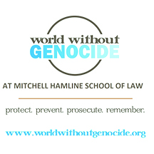

Dear Representative,
Please support legislation to designate every April as Genocide Awareness and Prevention Month. Thousands of families in our state have been devastated by these conflicts that have occurred around the globe. This designation will inspire people to remember those whose lives and cultures were destroyed. Many tragedies are commemorated in April including:
- April 3 – the Darfur genocide
- April 5 – anniversary of the siege of Sarajevo, Bosnia
- April 7 – Rwandan Genocide Remembrance Day
- April 17 – anniversary of the Cambodian genocide
- April 24 – Armenian Genocide Remembrance Day
- April 24 – Holocaust Remembrance Day
In 2008, the Genocide Prevention Task Force was convened by the United States Holocaust Memorial Museum, the American Academy of Diplomacy, and the United States Institute of Peace. Chaired by former Secretary of State Madeleine Albright, the Task Force reported that educating the public can help protect individuals and promote a culture of lawfulness to prevent future genocides. We urge you to say “never again” to these crimes and to bring us a step closer to a world without genocide.

Sincerely,

Name (please print)
_________________________________________
Address, City, State
_________________________________________
Email address
_________________________________________

