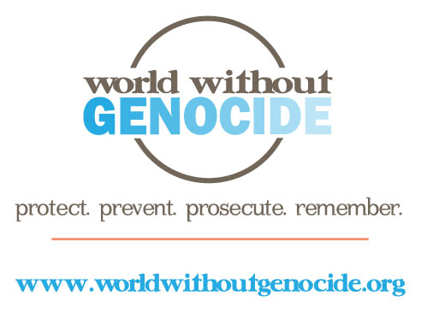

World Without Genocide
Minnesota Justice Foundation Opportunities
Fall 2014-Spring 2015

Coordinator, Study Trips, Israel and NY-DC- 1 position
World Without Genocide participates in a summer study-abroad program at Bar-Ilan Law School in Tel Aviv, Israel and organizes and leads an annual study trip to New York and Washington, DC for law students to explore careers in human rights.

The MJF student in this position will do the following for the study-abroad program in Israel, to be held in July 2015:
- Coordinate externships for law students at Palestinian and Israeli organizations;
- Arrange student and faculty transportation and housing;
- Prepare materials about current legal issues regarding nationality status, voting rights, etc. for Israelis and Palestinians;
- Prepare background materials about UN resolutions on the Israeli-Palestinian conflict;
- Coordinate panel discussions about Jewish and Muslim religious laws and practices;
- Arrange meetings with NGO peace advocates and leaders in West Bank and Israeli communities; and
- Other activities as appropriate.

The MJF student in this position will do the following for the spring break study trip to New York and Washington, D.C., to be held in March 2015:
- Arrange student and faculty transportation and accommodation;
- Coordinate all meetings with NGOs, elected officials, and staff at the US Holocaust Museum and United Nations;
- Prepare detailed agenda and biographical/organizational information for participants;
- Investigate internship and career opportunities and disseminate information to participants in advance of the trip.

Requirements:
- Prior participation in the Israel study-abroad experience and the New York-Washington, D.C. study trip;
- Strong organizational skills;
- Ability to work independently and to meet deadlines;
- Excellent written and oral communication skills;
- Time commitment: an average of 2-4 hours weekly.
The MJF position will report to Dr. Ellen Kennedy, Executive Director, World Without Genocide.

Applications are available at www.worldwithoutgenocide.org/mnissues
To apply: Submit a completed application, résumé, and a 200 to 250-word letter of intent to info@worldwithoutgenocide.org by August 25, 2014. For additional information, contact 651-695-7621.
Academic credit: Credit may be arranged for students at William Mitchell College of Law. Contact kennedy@worldwithoutgenocide.org.

