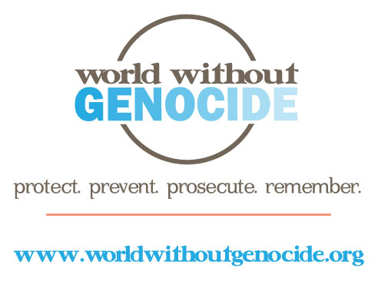

World Without Genocide
Minnesota Justice Foundation Opportunities
Fall 2014-Spring 2015

Research Associate, Rwanda, Bosnia, Cambodia – 3 positions
World Without Genocide’s website is used extensively by high school and college students as a resource on the history, background, and legal outcomes of various genocides. The website information for Rwanda, Bosnia, and Cambodia needs to be revised to reflect current legal issues.

The MJF students in these positions will do the following:
- Review the current material;
- Verify and edit the current content;
- Re-write the material to include recent outcomes at the following three tribunals:
- International Criminal Tribunal for Rwanda
- International Criminal Tribunal for former Yugoslavia
- Extraordinary Chambers in the Courts of Cambodia
- Include graphic design features where appropriate.

Requirements:
- Outstanding legal research skills;
- Significant knowledge of these three genocides;
- Ability to work independently and to meet deadlines;
- Excellent written skills;
- Time commitment: an average of 5 hours weekly through December 1.

Applications are available at www.worldwithoutgenocide.org/mnissues
To apply: Submit a completed application, résumé, and a 200 to 250-word letter of intent to info@worldwithoutgenocide.org by August 25, 2014. For additional information, contact 651-695-7621.
Academic credit: Credit may be arranged for students at William Mitchell College of Law. Contact kennedy@worldwithoutgenocide.org.

