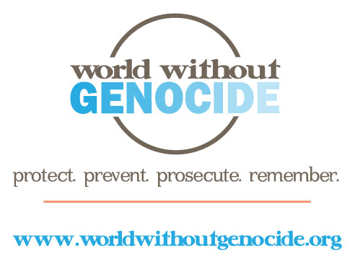

World Without Genocide
Minnesota Justice Foundation Opportunities
Fall 2014-Spring 2015

Editor, Current Prosecutions for Genocide - 1 position
World Without Genocide is preparing a volume of papers about current and recent prosecutions of perpetrators of genocides and mass killings from the Holocaust to current crises in Congo and Darfur. The anticipated publication date is December 2014.

The MJF student in this position will do the following:
- Edit the papers for factual accuracy;
- Edit the papers for appropriate format and uniformity of tone across all submissions;
- Solicit input for the volume from experts in the international human rights field;
- Add graphic design content where appropriate.

Requirements:
- Outstanding legal research skills;
- Knowledge of genocides from the Holocaust to the present;
- Familiarity with a range of current and recent cases on the topic;
- Ability to work independently and to meet deadlines;
- Excellent written skills;
- Time commitment: an average of 3-5 hours weekly through December 1.

Applications are available at www.worldwithoutgenocide.org/mnissues
To apply: Submit a completed application, résumé, and a 200 to 250-word letter of intent to info@worldwithoutgenocide.org by August 25, 2014. For additional information, contact 651-695-7621.
Academic credit: Credit may be arranged for students at William Mitchell College of Law. Contact kennedy@worldwithoutgenocide.org.

