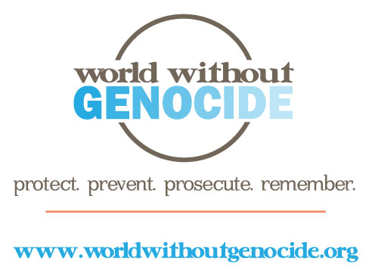

World Without Genocide
Minnesota Justice Foundation Opportunities
Fall 2014-Spring 2015

Brittany Nicholls Clinic For and About Battered and Abused Women – 2 positions
Gender-based violence is endemic in our local communities and around the world. Brittany Nicholls, Mitchell alumna and World Without Genocide associate, coordinates an annual clinic to be held on Thursday, April 9, 2015 at William Mitchell College of Law with the following components:
- A job fair of organizations that provide safety and support for abused women will inform about their services and internship, volunteer, and career opportunities;
- A legal clinic staffed by lawyers and law students to prepare orders for protection and other legal services at no cost;
- A speaker panel of leaders from local organizations shares information about national and international advocacy to end violence against women, with CLE credit available.

MJF students will work with Ms. Nicholls to plan, promote, and implement the Clinic. The students will:
- Contact leaders from local organizations to participate;
- Arrange the speakers’ panel;
- Coordinate lawyers and law students to staff the legal clinic;
- Organize a drive to gather donations of clothing and other necessities for a local women’s shelter;
- Solicit grant funding for honoraria, print materials, and refreshments;
- Prepare information to seek CLE credit for the speaker panel;
- Plan and implement publicity and outreach for the clinic, including participation in radio and TV interviews as available; and
- Organize and run the clinic.

Requirements:
- Strong organizational skills
- Ability to work independently and to meet deadlines
- Excellent written and oral communication skills
- Ability to work with a wide range of people
- Time commitment: an average of 2-4 hours weekly through April 9.

Applications are available at www.worldwithoutgenocide.org/mnissues

To apply: Submit a completed application, résumé, and a 200 to 250-word letter of intent to info@worldwithoutgenocide.org by August 25, 2014. For additional information, contact 651-695-7621.
Academic credit: Credit may be arranged for students at William Mitchell College of Law. Contact kennedy@worldwithoutgenocide.org.

