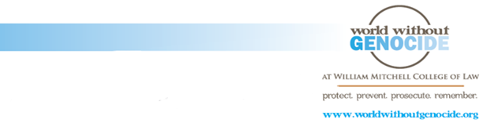

Order form
‘Upstanders: Ending Modern Slavery’ educational materials, $10 each*

Quantity | Total Due
*Includes: CD with ‘Upstanders’ script and presentation, additional educational resources, and shipping.

Checks payable to World Without Genocide. Please return this form to a World associate or mail to World Without Genocide, 875 Summit Avenue, St. Paul, MN 55105
Name
Address

Phone number Email

875 Summit Ave, St. Paul, MN 55105 admin@worldwithoutgenocide.org 651-695-7621

[ Detach bottom half for customer. ]

Receipt
‘Upstanders: Ending Modern Slavery’ educational materials, $10 each*

Quantity | Total Due
*Includes: CD with ‘Upstanders’ script and presentation, additional educational resources, and shipping.

Your order will be processed within 5 business days.
Questions? Please contact Christie Nicoson, Program and Operations Coordinator
nicoson@worldwithoutgenocide.org 651-695-7621

875 Summit Ave, St. Paul, MN 55105 admin@worldwithoutgenocide.org 651-695-7621

