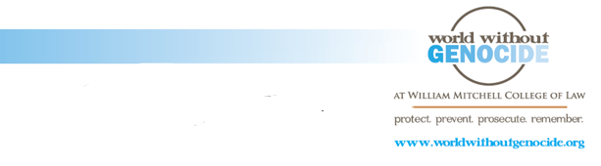

*Towards a Conflict-Free Campus, Organization, City, and State*

For more than a decade, the Democratic Republic of the Congo has suffered intense conflict, particularly in the eastern region which is rich in minerals like tin, coltan, tungsten, and gold. These high-demand minerals are used in all consumer electronics: phones, computers, music players, and cameras. Armed groups compete for access to these resources, exploiting the land and devastating local populations.

Mortality rate:

**45,000 per month**



Over 5,000,000 civilians have died, making this **the deadliest conflict since World War II**. About 45,000 people die every month due to famine, disease, killings, and sexual violence.

**The Dodd-Frank Wall Street Reform Act of 2010** mandates that if companies use minerals from Congo or an adjoining country, they must file a report with the U.S. Securities and Exchange Commission describing what they have done to ensure the source of the minerals.

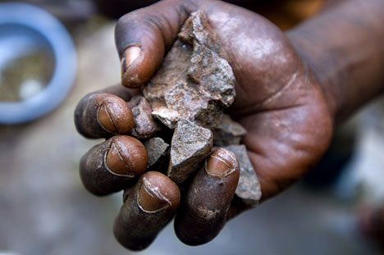

Under this law, **companies are responsible for identifying where their suppliers get the minerals**. Companies must verify these steps through an audit of their reporting. Although this law is an important first step, it does not establish penalties for companies that continue to get minerals from conflict areas.

Change begins with consumers

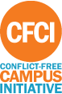

**The Conflict-Free Initiative,** started by the Enough Project, is a national campaign to build support for conflict-free electronics. Students, schools, organizations, cities, and states have immense power because they are consumers of computers, lab equipment, and other electronic products. We can stop financing war in eastern Congo. We can pressure major electronic companies to pursue responsible practices in line with the Dodd-Frank Act because we demand conflict-free products.

Information from [www.enoughproject.org](http://www.enoughproject.org).